Instructions

How to run reports for outstanding Travel Requests and Expense Reports

Note: Only a limited number of people have access to run these reports. At least one person in each college/division has been given access.

1. From Concur home page under Reporting, click on Intelligence.

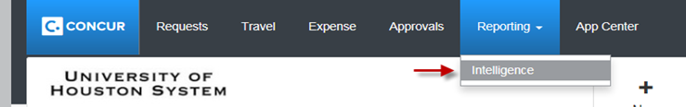

1. Open folder University of Houston System.

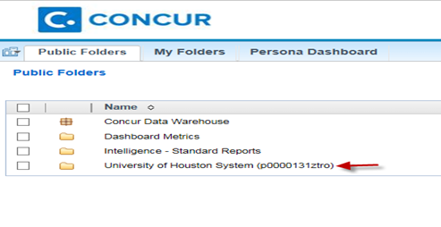

1. Open folder User Reports

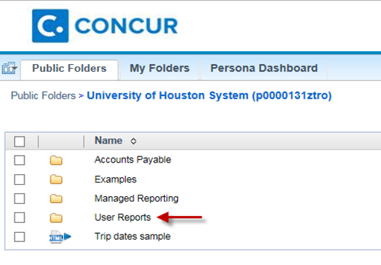

1. You can choose either Outstanding Expense Reports or Outstanding Travel Requests.

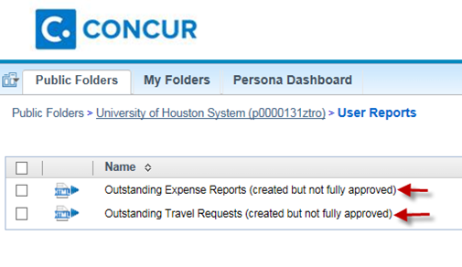

1. From the report, click on the icon cid:image015.png@01D1E37C.6247D660in order to print the report in Excel format.

